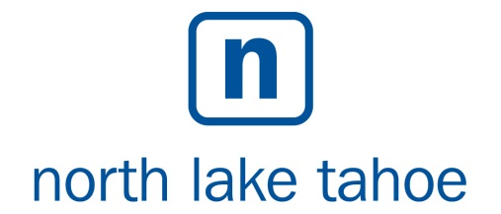
AGENDA
Board Meeting
Lake Tahoe Incline Village Crystal Bay Visitors Bureau
Wednesday, June 17th, 2015

The Board of Directors of the Lake Tahoe Incline Village Crystal Bay Visitors Bureau will hold their monthly meeting on Wednesday, June 17th, 2015, beginning at 3:30 p.m. The meeting will be held in the board room of the Incline Village Crystal Bay Visitors Bureau, 969 Tahoe Blvd., Incline Village, NV 89451.

Public Comment will be at the beginning and ending of this meeting, and is limited to three minutes. The public is encouraged to comment on all agenda items as well as issues not on the agenda during the Public Comment period. Agenda items may be taken out of order, may be combined for consideration by the Board, and may be removed from the Agenda at any time. Members of the public desiring to speak must complete a “Request to Speak” form and return it to the IVCBVB clerk at the beginning of the meeting. Comments based upon viewpoint may not be restricted by the Board.

- Call to Order/Roll Call Lee Koch
- PUBLIC COMMENT – Pursuant to NRS 241.020 Lee Koch
This is the time for public to comment on any matter whether
or not it is included on the Agenda of this meeting.

- Approval of Agenda – (For Possible Action) Lee Koch
- Approval of Board Minutes from the Meeting of Lee Koch May 6th, 2015 – (For Possible Action)

- Executive Director’s Report Andy Chapman
  - Revenue Report
  - Marketing Indicators
  - CEO Written Activity Report

- Review and Approval of FY 2015/16 Budget Andy Chapman
(For Possible Action)

- Review of FYE 2014/15 Budget Audit Process - Andy Chapman
(For Possible Action)

- Review and Approval of Capitalization Policy Andy Chapman
(For Possible Action)

- Review and Approval of NLT Coop Agreement Lee Koch/
(For Possible Action) Geno Menchetti

- Appointment of new Board Member Heather Bacon
(For Possible Action)

XI. Appointment of FY 2015/16 Officer Positions Lee Koch/
(For Possible Action) Andy Chapman

XII. Appointment of NLT Marketing Coop Committee Members Lee Koch/
(For Possible Action) Andy Chapman

XIII. Approval of Special Event Funding Bill Wood
(For Possible Action)

- Recognition of Outgoing Board Member Bill Watson Lee Koch
- Old Business Lee Koch
- New Business Lee Koch
  - Support Letter Request for Mark Twain Trail Display

- PUBLIC COMMENT – Pursuant to NRS 241.020 Lee Koch
This is the time for public to comment on any matter whether
or not it is included on the Agenda of this meeting.

- Adjournment – (For Possible Action)

Physically disabled persons desiring to attend this meeting should contact Tricia Davis at (775) 832-1606.

Support materials can be found at http://www.gotahoenorth.com/about-tahoe/business-and-community/incline-village-crystal-bay-visitors-bureau

Public Postings:
Incline Village Post Office IVGID Office
Crystal Bay Post Office Incline Justice Court
Incline Village Crystal Bay Visitor Bureau Meeting Location

Submitted by
Tricia Davis

